SECTION 3. INSTALLATION

INTRODUCTION

As with any sophisticated communications device, installation of the ARIA-300 System requires the care and fore thought of a competent technician. Installation proceeds in 5 major steps;

- Site Preparation
- KSU and PSU Installation
- PCB Installation
- System Wiring
- System Programming and Verification

By utilizing the instructions that follow, the installation is quick and efficient. Directions for System Programming are briefly given in SECTION 6. CUSTOMER DATABASE PROGRAMMING.

SITE PREPARATION

General Site Consideration

The first step is to locate an acceptable site for the common equipment (KSUs, boards, etc.). When locating a mounting site for the KSUs, the following points must be considered;

a) The KSUs are designed for wall-mounting and should not be mounted directly to a masonry or plaster- board wall. It is recommended that a 1/2 plywood back-board be firmly mounted to the wall, and the KSU and the MDF, if other than the MDF, be mounted to the back-board.

b) The location must have access to a dedicated 220 Volt AC, 50-60 Hz circuit with a circuit breaker or fuse rated at 15 amps. A GPO grounded outlet should be within approximately 2 meters (6 feet) of the lower left rear of the KSU mounting.

c) Each KSU shall be connected to a protective earth installed by a qualified person. A separate cable should be installed between each KSU and the earth source.

d) The system should be located in an area which is well ventilated with a recommended temperature of 20-26 degrees C (68-78.8 degrees F) and a relative humidity of 5-90 % (non-condensing).

e) The system should be located within 8 meters (25 feet) of the telephone company's termination point. Also, the location should be within the prescribed station loop lengths for all keysets and terminals. If existing cabling is to be employed, the location of existing cabling and conduits should be considered.

f) The location should have adequate accessibility, space and lighting for future servicing and should consider the need for future expansion.

g) The site should be away from radio transmitting equipment, arc-welding devices, copy machines, and other electrical equipment capable of generating electrical interference. The system should be protected from flooding and heavy machinery as well as excessive dust and vibration.

Back-Board Installation

A wooden back-board is recommended for all installations and must be installed when the location has masonry or plaster-board walls. A 0.5 inch plywood material is sufficient for most installations. The back-board should be mounted at a convenient height, about 1 meter above the floor, and be bolted in a number of places to distribute the weight of the system.

Space should be available on the bottom side of the back-board for the MDF and/or other MDF and for optional equipment such as a music source and PFTU, etc.

Verify On-Site Equipment

Once the equipment installation site has been identified and a dedicated AC outlet, earth ground, and lighting and ventilation are available, verify that all equipment required is on-site and has not been damaged during shipment. Assure there is no shipping damage. Note that a mounting template is packed with KSU and this template will be required later in the installation. Check that the type and quantity of boards received is correct and optional equipment and a Power Line Surge Protector are on-site. Note that the individual boards should not be unpacked at this time.

If any equipment is damaged or missing, notify appropriate personnel to correct the situation.

KSU INSTALLATION

ARIA-300 system consists of three KSUs, 1st, 2nd and 3rd KSU. The 2nd and the 3rd are used for expansion KSU.
Caution :
- Installing 1st, 2nd and 3rd KSU together on the brick wall can cause the connection between Basic and Expansion KSU to be unstable. So we recommend that three KSUs should be installed on the flat wall.
- Power on procedure after installation:
- Power on sequence - 3rd KSU → 2nd KSU → 1st KSU
- After all KSUs are powered on, you must reset MPB.

Mounting 1st ,2nd and 3rd KSU

The 1st KSU is metal frame cabinet designed for wall mounting. The KSU must not be mounted on a masonry or dry-wall surface, in this case a wooden Back-Board is required, reference paragraph Back-Board Installation. The distance between mounting holes and the position of mounting holes is shown in Fig 3.3.2 ~ 3.3.3.
The KSU is mounted with four #10 or larger, 1.5 inch or longer screws.
First, drill pilot holes in the two locations marked, insert the screws and tighten leaving about 0.5 inch exposed. Mount the KSU on the screws and tighten the screws securely.

The 2nd and 3rd KSU for expansion is a metal housing designed for wall mount installation as the 1st KSU.
The 2nd KSU is mounted in a manner similar to the 1st KSU, refer to Fig 3.3.3. Select the positions of two holes to fix 2nd KSU on the wall so that the proper connection between 1st KSU and 2nd KSU will be possible. Mount the 2nd KSU on the screws and tighten the screws securely. And insert the 4 fasteners in the both left and right side. Fasten the fasteners with 8 screws between the 1st KSU and 2nd KSU, refer to Fig 3.3.5.
When the 3rd KSU is installed, the 3rd KSU is mounted in a manner similar to the 2nd KSU, refer to Fig 3.3.3 and Fig 3.3.6.

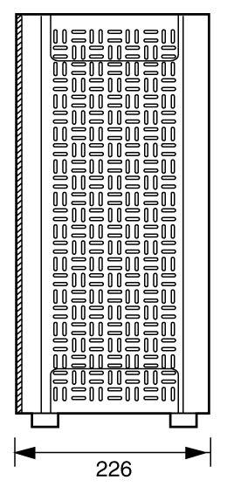
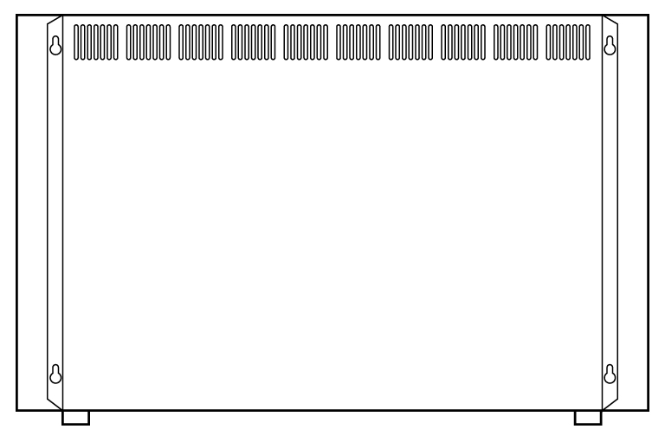
Side View
Rear View
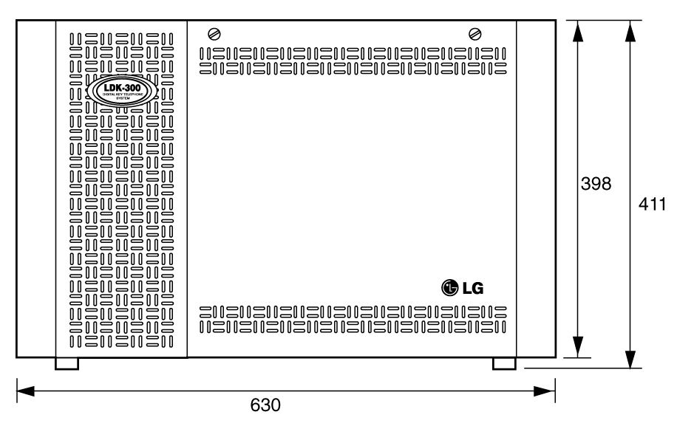

Front View

Fig 3.3.1 KSU Exterior

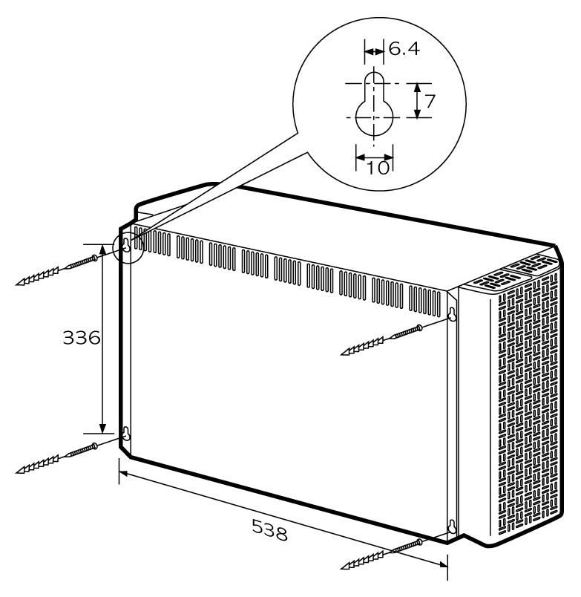
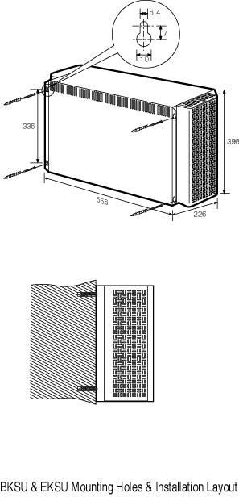

Fig 3.3.2 1st KSU Mounting Holes & Installation Layout

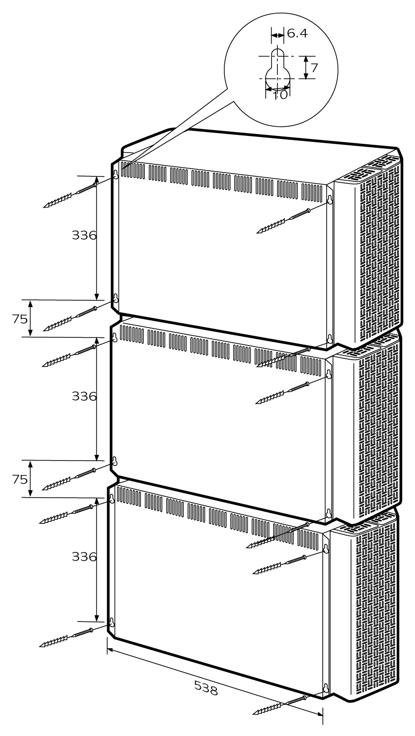

Fig 3.3.3 1^{st,} 2nd and 3rd KSU Mounting Holes & Installation Layout 1

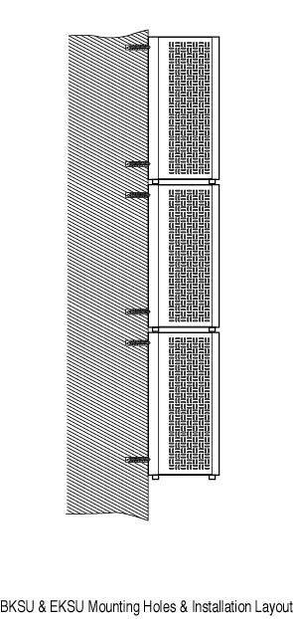

Fig 3.3.4 1st, 2nd and 3rd KSU Mounting Holes & Installation Layout 2

Fig 3.3.4 1st, 2nd and 3rd Mounting Holes & Installation Layout 2

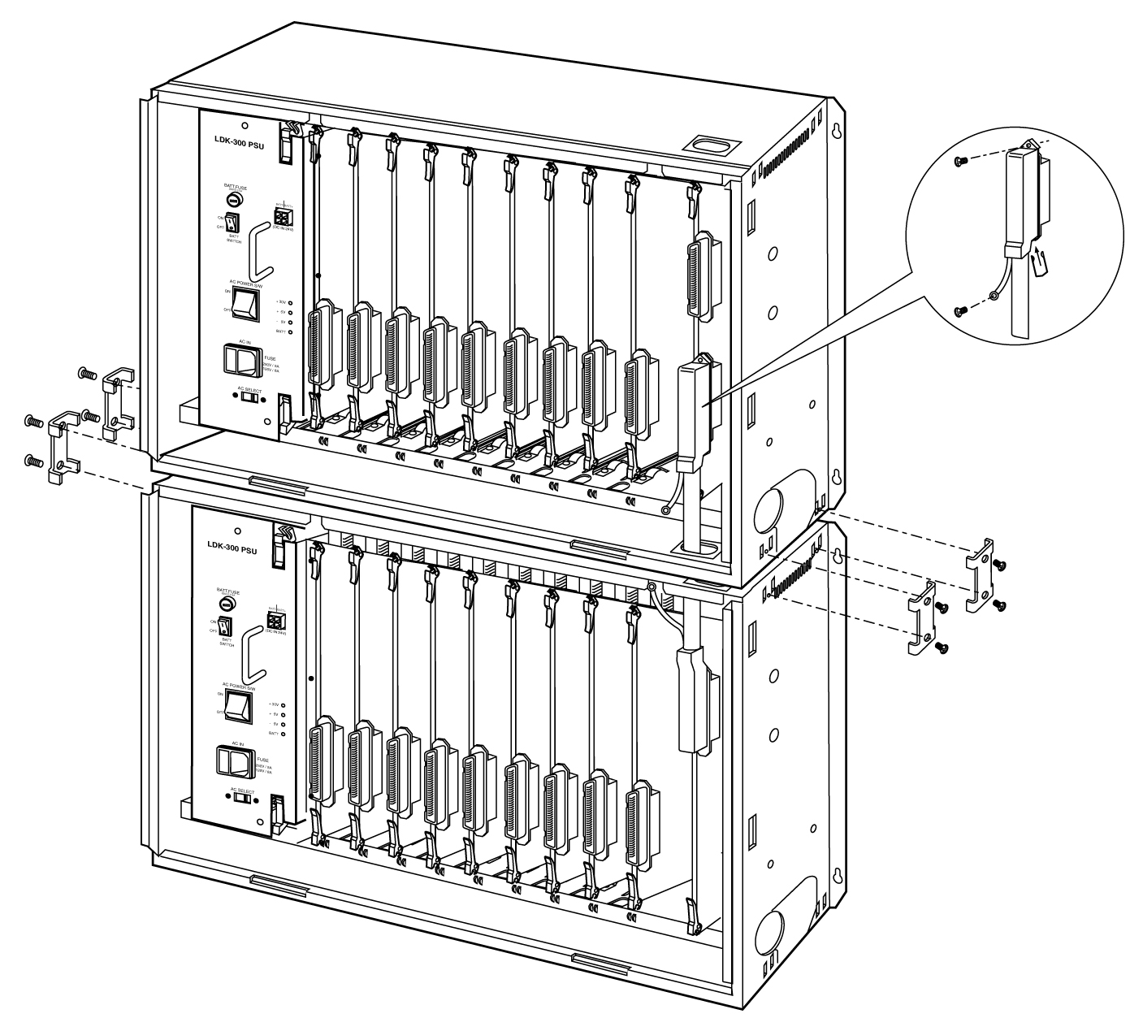

Fig 3.3.5 Connection between 1st KSU and 2nd KSU

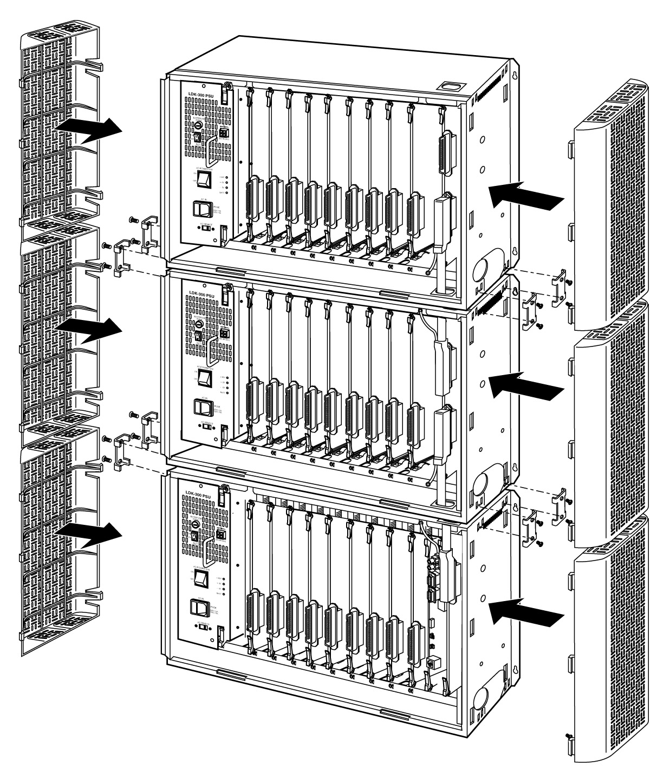

Fig 3.3.6 Connection between 2nd KSU and 3rd KSU

Reserved

RGU Installation

The Ring Generator Unit is needed in the 1st, 2nd and 3rd KSU if SLIB24, SLIB48,SLIBII, and DSIB are to be installed, to provide Ring voltage and Message Wait Source.
The RGU is fixed on the right bottom side panel with the two screws provided inside the KSU and is connected to CN14 (marking on PCB) connector on the system back-plane of KSU.
See Fig 3.3.8.

KSU
Fig 3.3.8 The installation of RGU

RGU
CN14
On MB

The cable for connecting between RGU and KSU is provided with RGU.

PFTU Installation

The PFTU provides the relay contacts for the direct connection of 6 Exchange Lines (CO Lines) to 6 Extension Lines (SLT Lines) in event of a power or processor failure. The PFTU can be optionally installed on the right upper side of every KSU.
2 control wires are connected to the CN15 (marking on PCB) on back-plane of the system as Fig. 3.3.8 regardless of the polarity of control wires. The connector for CN15 is provided but control wires should be got locally. The specification of control wires is AWG #22, #24 or #26 regardless of their length.
A RJ21 type connector, which consists of 25 pairs, is connected CO line, LCOB, SLIB and SLT as section 3.5.5 PFTU Wiring.
An earth terminal is provided, and the grounding method of the PFTU is shown in Fig 3.3.10 when the PFTU is installed outside KSU. And there is a test switch on the surface of PFTU; TEST position of the switch is used for testing PFTU function, and NORMAL position of the switch for normal operation.

In case of KSU, a PFTU can be installed on the frame of KSU in the system. Its position is the right upper side of RAU. See Fig 3.3.10 for connection earth cable.

Fig 3.3.9 The exterior of PFTU

KSU Grounding

Before connection to the mains supply, the Aria-300 system must have a hard-wired protective earth installed by a qualified person. The protective earth is required for user safety and also to minimise EMC interference.

A separate cable should be used between the ground source and the KSU, UL 1015 AWG #18 or larger copper wire is recommended. The wire should be kept as short as possible, it is recommended that the wire be no longer than 1 meter (about 3.28 feet).

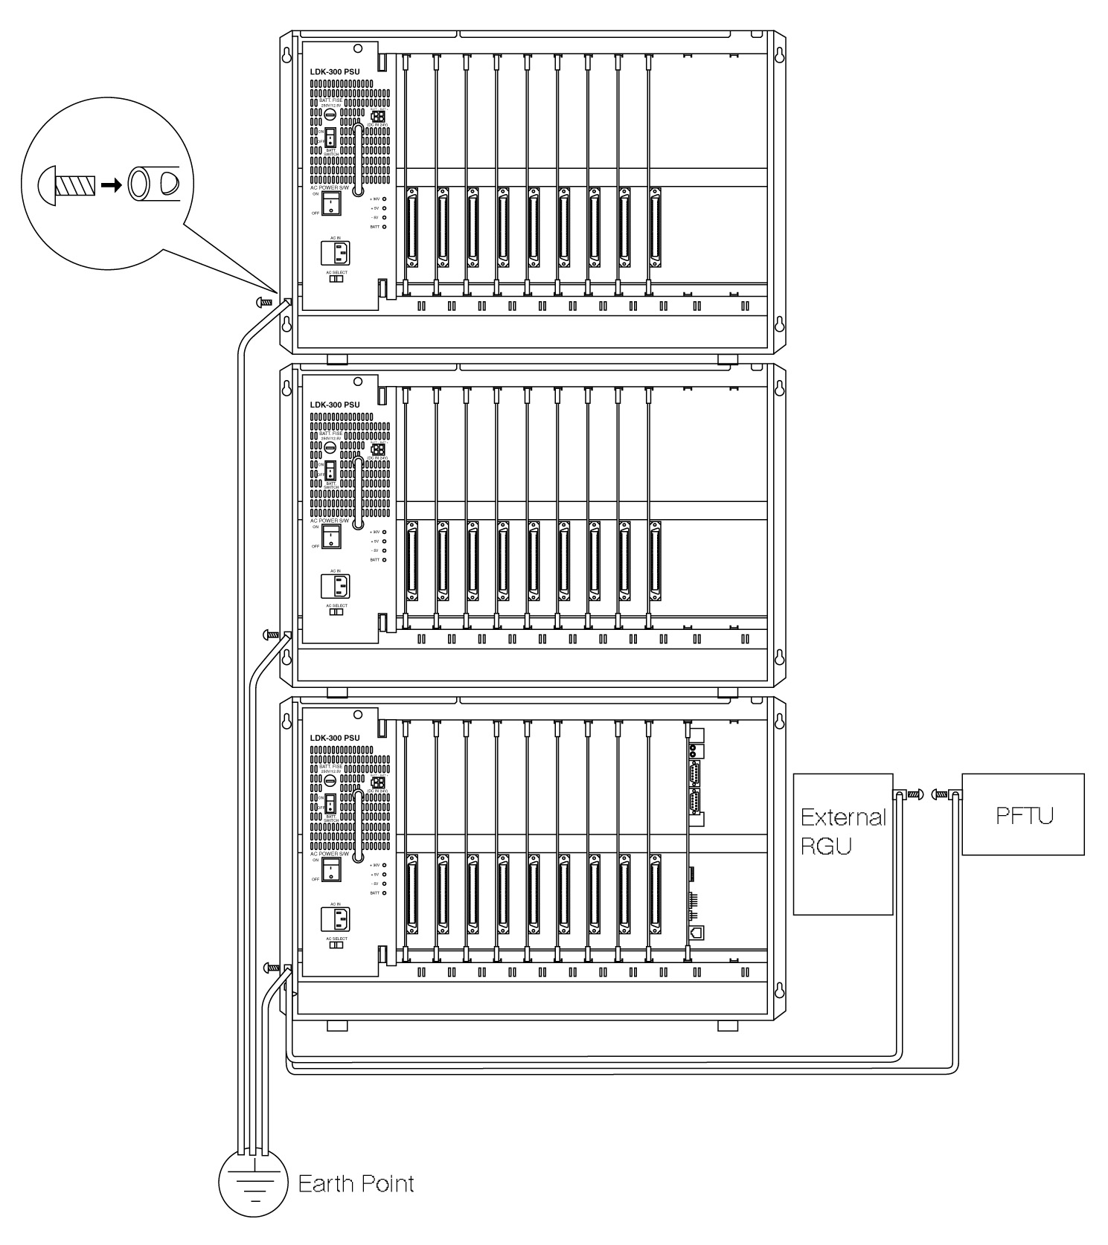

Connecting Wire: 1. UL 1015 AWG#18 or larger than this.
2. Length ≤ 1 meter * The shorter the length of wire is, the better it is.
3. Color : Green / Yellow

Fig 3.3.10 The Connection Method of Earth Cable between KSU and PFTU.

PSU Installation

The Power Supply Unit (Fig 3.3.11.a) provides power for the system boards and telephones, converting the AC Voltage input to appropriate DC voltages.
Before installation, assure that the AC plug is not plugged into the AC outlet. Place the PSU in the left most slot in the KSU, aligning the card guides with the PSU PCB and PSU frame flanges. Slide the PSU into place using the injectors to seat the PSU fully in the KSU. And then fix the PSU to the KSU with two screws as Fig 3.3.11.b.
The PSU can operate from either 110/115 or 220/230 Volts AC based on the setting of the VOLTAGE SELECTOR Switch on the lower front of the PSU. Generally the PSU is shipped with this switch set for 220/230V AC.
For Australia, ensure that the A. C. select switch displays 230V.

The range of mains input voltage and the fuse ratings of the ARIA-300 PSU according to the position of VOLTAGE SELECTOR switch are as follows;

Position of VOLTAGE SELECTOR | The Range of Mains Input Voltage | Fuse Ratings  ARIA-300PSU
AC 230V | 187V AC ~ 264V AC | 4A / 5A @250V
Table 3.3.1 Fuse rating of PSU3 and ARIA-300 PSU

PSU capacity is as follows;
Unit: A
PSU Type | +5V DC | -5V DC | +30V DC | Battery
ARIA-300 PSU (SMPS) | 10 | 1.5 | 8.4 | 1A
Table 3.3.2 Power Capacity of ARIA-300 PSU

3.3.7 Removal of Power from KSU

Procedure to remove power from an Aria-300 KSU
- First determine if the PSU has a battery back up (BBU) installed by checking if a battery cable lead is connected to the BBU input socket mounted on the front of the PSU, the socket is labelled “DC IN 24V”.
- If a BBU is installed, turn the “BATT SWITCH“ on the PSU to OFF.
- Most batteries will have an ON/OFF switch or a circuit breaker fitted to the battery, turn this OFF as well.
- Unplug the battery cable from the “DC IN 24V” socket on the PSU.
- Turn the “AC POWER SWITCH” mounted on the PSU to OFF.
- Unplug the power cable from the “AC IN” socket on the front of the PSU.

PCB INSTALLATION

PCB Handling and General Installation

All boards should not be installed or removed with power applied.
Power must be turned off prior to insertion or removal of the PCB.
The system PCBs contain digital circuitry which, while extremely reliable, can be damaged by exposure to excessive static electricity. When handling PCBs, a grounded wrist strap should be used to protect the boards from static discharges. Also, use common sense when handling the PCBs. For example, do not place a PCB in locations where heavy objects might fall on the PCB and damage components.
To insert a PCB, hold the PCB by the injectors and, with components facing right, align the top and bottom edge of the PCB in the card guides. Slide the card into the system and use the injectors to seat the PCB firmly into the back plane connectors. To remove a PCB, reverse the procedure. Installation method of PCB is shown in Fig 3.4.1.
* Note : Take caution when inserting the MPB and LMU to prevent the DIN connector pins, (male pins) of MB, from being bent. Insert carefully.
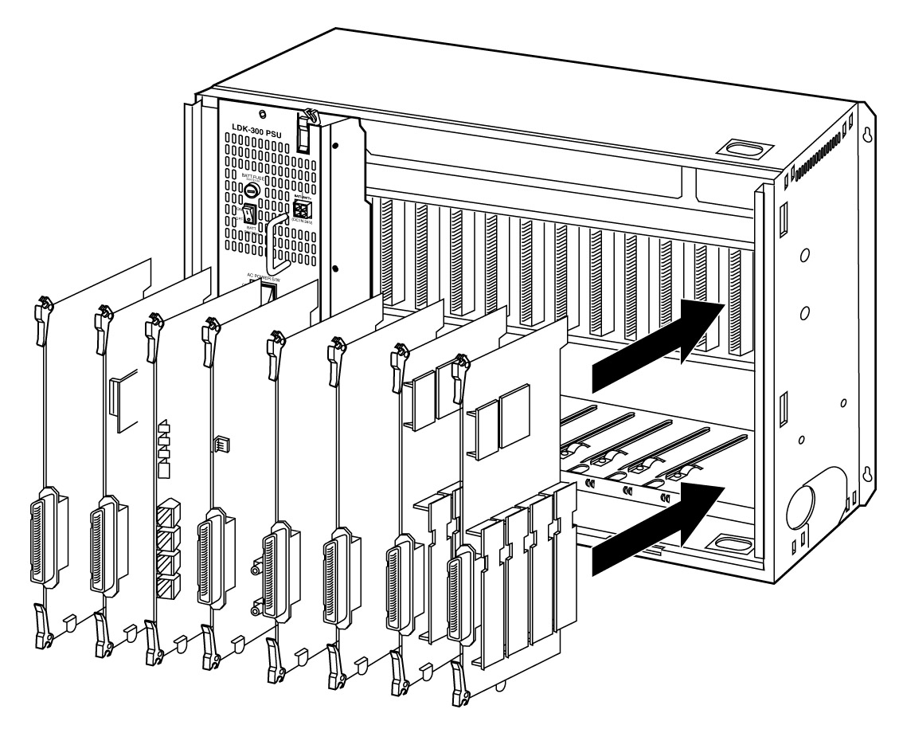

Fig 3.4.1 PCB Installation

MPB Installation

The MPB is installed in the MPB PCB card slot (slot MPB) of the only 1st KSU. The MPB may be equipped with 3 add-on boards; PMU for software program, a MODU for modem access to the system, and a SDRAM for software downloading and additional features. See Fig 3.4.2.
Lithium Battery
The MPB contains a lithium dry-cell to maintain memory and real-time clock functions. The battery is soldered on the MPB, and connected circuitry by on-off DIP switch. So the switch is set to ON position before the MPB installation.

“ CAUTION : Danger of explosion if battery is incorrectly replaced. Replace only with the same or equivalent type recommended by the manufacturer. Dispose of used batteries according to the manufacturers instruction.”
SW3

Fig 3.4.2 MPB, PMU and MODU configuration
Function of SW3
The MPB also has an eight-position DIP switch, SW3. The function of each switch position is as followings;
Default setting: All ON position
Switch | Function | OFF | ON
1 | Administration Programming Access | Disable | Enable
2 | CTS (Clear to Send) of RS-232C | Enable | Disable
3 | Command/Event Trace (The purpose of testing software) | Enable | Disable
4 | Not used | - | -
5 | SMDI (Simplified Message Desk Control –Voice Mail ) | SMDI ON | SMDI OFF
6 | Not used | - | -
7 | Power up status trace of board | Enable | Disable
8 | Database default on power up | Disable | Enable
Table 3.4.1 The function of each pole of SW3

Before programming the system, switch 8 should be placed in the on position and power cycled off and on to initialize the system database to default. Once the database has been initialized, switch 8 should be placed in the off position so as to protect the database.
After the lithium batteries(SW2 ON) and Add-on boards installed, insert the MPB in slot MPB of KSU.

Function of various switches and connectors
Switch/Connector | Functions | Remark
SW1 | CPU Reset
SW2 | Lithium Battery ON/OFF switch
CN1 and CN2 | MODU connection
CN3 AND CN4 | RS-232C Serial Interface | System Access
CN6 | BDM connection | Development only
CN7 | Card Edge connection
CN8 and CN9 | PMU connection
PJ1 and PJ2 | External paging and MOH connection | Note 1
S1 | SDRAM module connection
MJ1 | LAN connection | Note 2
Table 3.4.2 Function of various switches and connectors

* Note:
- MPB should be installed in MPB slot in the only 1st KSU.
- The DIP switch, SW2 should be turned ON position before the MPB installation to protect system data in the case of a power fail.
- The 8th pole (switch 8) of SW3 should be OFF to protect the variety features by Admin programming after the system power up and initialization. See Table 3.4.1.
- When the system power is on, the default slots will be automatically redefined from the most left slot if the 8th pole of SW 3 is set to ON position. So It is recommended that a board among DTIB12, DTIB24 and DSIB is installed in the most left slot and a Digital Keyset with display is connected to the first port the board when the first initialization of the system, since the FIRST STATION of the system can only access the system database without PC Administration.
- Add-on boards: PMU, MODU, SDRAM module
Note: 1 – An ACA approved LIU must be installed to the external paging and MOH port.
Note: 2 – An ACA approved Ethernet LIU must be installed.

PMU Installation

The MPB should be equipped with PMU for system operation. Before installing the MPB, install PMU. Refer to Fig 3.4.2.
The PMU should be installed on MPB through the dual line connectors, CN8 and CN9 of MPB, so recommend visual inspection of the connecting state between MPB and PMU after installing it on MPB.

SDMU32 Installation

The MPB may be equipped with 32M bytes SDRAM module for memory expansion and the software download, and additional features. Before installing the MPB, install SDRAM module if required, refer to section 2.4.11.2. The SDRAM module should be installed on the position of SDRAM(S1) on MPB.
The SDRAM module should be installed on MPB through 168 pin connectors, so recommend visual inspection of the connecting state between MPB and SDRAM after installing it on MPB.

MODU Installation

The MODU is used for remote access the system for system maintenance and PC based administration function. MODU can be installed on MPB through CN1 and CN2 of MPB. Refer to Fig 3.4.2.

MISB Installation

The MISB contains 2 MOH inputs, 2 external paging ports and four dry contacts, and an alarm detection.
Connectors/Switches | Function | Remark
CONN1 | SIU Connection
CHAMP1 | RJ21 type female connector(25-pair Amphenol) for External Paging, External MOH, Relay contacts, and Alarm Input | See the clause 3.5.3
Table 3.4.3 Function of various connectors on MISB

One MISB can be installed in the slot No. 9 in the only 1st KSU.
SIU can be installed on MISB.
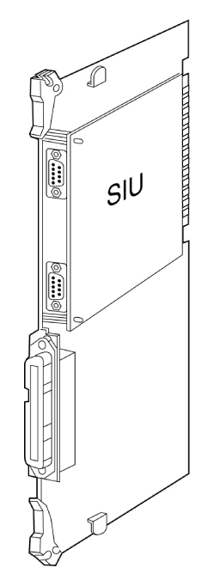

Fig 3.4.3 MISB & SIU Installation

SIU Installation

The SIU board is used for system maintenance, PC based Admin, SMDR print and SMDI. The system supports up to 4 Serial Interface circuits, 2 circuit on MPB and additional 2 circuits on SIU board.
Followings are the list of the system’s output;
- Administration database
- Off-line SMDR (on-demand)
- On-line SMDR
- Statistical Information
- SMDI (voice mail)
- System trace data
* Note:
- A SIU board can be installed only on MISB.
- SIU should be fixed on MISB with two plastic supporters and two screws provided.

Extension Board Installation

The system can be equipped with any combination of the extension boards; DTIB12, DTIB24, SLIB24, SLIB48, SLIBII, DSIB, and WTIB. The station interface boards can be installed in any card slots in KSU. But WTIB can not be installed in slot 9 of every KSU.
It is recommended to install extension boards, e.g. DTIB from the left most slot (slot No.1). Also, since the first port of SLOT # 1 will be the database access port, it is recommended that a DTIB be installed in this slot and a Digital Keyset with display be connected to this port.

DTIB12/DTIB24 Installation

DTIB12/DTIB24/DSIB can be installed in any card slot in universal slot in KSU.
Since the first port of SLOT 1 will be the database access port, it is recommended that a DTIB12, DTIB24 or DSIB be installed in this slot and a digital keyset with display be connected to this port.

Function of LEDs
LED | Function | Remark
LED1 | The status of ports. (ON: in use, OFF: idle)
Table 3.4.4 LEDs on DTIB12/24
Function of connector
Connector | Function | Remark
CHAMP1 | RJ21 type female connector for terminal connection.
Table 3.4.5 connector on DTIB12/24

- Note:
- The distance between Digital Terminal Interface Board and Digital Terminal: see Table 2.3.5

In ARIA-300 system, LKD-30DS with 2B-module and secondary terminal can be connected to only every even-numbered port (0,2,4,…) of DTIB12/DTIB24/DSIB, then any digital terminal can not be connected to the consecutive odd port(1,3,5,…) in that case. See clause 2.4.12.3 2B-module and clause 2.4.12.4 GDK-PC PHONE in section 2 for more details regarding 2B-module and CTI module.

CHAMP1

Fig 3.4.4 DTIB

DTIB12/DTIB24 can be installed in any of slot No. 1-9 in KSU.
So It is recommended that a board among DTIB12, DTIB24 and DSIB is installed in the most left slot and a Digital Keyset with display is connected to the first port the board when the first initialization of the system, since the FIRST STATION of the system at first can only access the system database without PC Administration. See clause 3.4.2 MPB Installation.

SLIB24/SLIB48 Installation

SLIB24/SLIB48 can be installed in any universal slot and allows 6 single line analogue devices to be connected. A MSGU/MSGU48 with 6 circuits can be optionally installed on SLIB24/SLIB48 respectively to light a message waiting lamp in the SLT connected to SLIB24/SLIB48, and a DTRU with 2 receivers can be optionally installed on SLIB24/SLIB48 to receive DTMF signals.

Function of LED
LED | Function | Remark
LED1 | The status of ports. (ON: in use, OFF: idle)
Table 3.4.6 connector on SLIB24/48
Function of various connectors
Connector | Function | Remark
CONN1 and CONN2 | DTRU connection
CONN3 and CONN4 | MSGU and MSGU48 connection | 1)
CHAMP1 | RJ21 type connector (female) for terminal connection
Table 3.4.7 connector on SLIB24/48

- Note:
- If you want Message Waiting function on SLIB24 or SLIB48, MSGU or MSGU48 should be installed on SLIB24 or SLIB48 respectively. MSGU can be installed on SLIB24, and MSGU48 can be installed on SLIB48.
- The distance between SLIB and SLT: see Table 2.3.5

SLIB24/SLIB48 can be installed in any of slot No. 1-9 in KSU .
Add-on boards: DTRU, MSGU(on SLIB24), MSGU48(on SLIB48)

DTRU

MSGU
or
MSGU48

CHAMP1

Fig 3.4.5 MSGU/MSGU48 and DTRU Installation

SLIBII Installation

SLIBII can be installed in any universal slot and allows 12 single line analogue devices to be connected. A MSGUII with 12 circuits can be optionally installed on SLIB II to light a message waiting lamp in the SLT, and a DTRU II with 4 receivers can be optionally installed on SLIB II to receive DTMF signals.

Function of LED
LED | Function | Remark
LD1 | The status of ports. (ON: in use, OFF: idle)
Table 3.4.8 LEDs on SLIBII

Function of various connectors
Connector | Function | Remark
CN2 and CN4 | DTRUII connection
CN3 and CN5 | MSGUII connection | 1)
CN1 | RJ21 type connector (female) for terminal connection
Table 3.4.9 connector on SLIBII

- Note:
- If you want Message Waiting function on SLIBII, MSGUII should be installed on SLIBII.
- The distance between SLIBII and SLT: see Table 2.3.5

SLIBII can be installed in any of slot No. 1-9 in KSU
Add-on boards: DTRU II, MSGU II
CN1

MSGU II

DTRU II

Fig 3.4.6 MSGU II and DTRU II Installation

3.4.4.4 SLIB2E Installation

SLIB2E can be installed in any universal slot and allows 12 single line analogue devices to be connected. Two MSGU48 can be optionally installed on SLIB2E to light a message waiting lamp in the SLT, and a DTRU4 with 4 receivers can be optionally installed on SLIB2E to receive DTMF signals.
LDK-300 SLIB2E Iss: Rev:
CN8
●
DTRU4
SERVICE
NORMAL
ON:COUNTRY
OFF:CTR21
●
●
CN6
CN5
CN7
●
MSGU48
MSGU48
101
101

CN1

SW1

CN2

Fig 3.4.7 SLIB2E and MSGU48 configuration

Function of Switch
SW | Function | Remark
SW1 | Mode selection switch  ON : Country mode  OFF : CTR21 mode | 1), 2)
SW2 | Upper Side - Normal Operation(short loop)  Lower Side - Service Position(long loop) | 3), 4)
Table 3.4.11 Switch on SLIB2E
Note:
1) Country mode : H/W gain and transmission characteristics depend on Each country Spec.
2) CTR21 mode : H/W gain and transmission characteristics depend on CTR21 Specification.
3) LDK-300 does not support the function of normal/service selection.
4) SW2 is used for selection of short loop or long loop in special country.
[ special country( impedance = 600ohm ) : Standard, India, Israel, China ]

Function of LED
LED | Function | Remark
LD1 | The status of ports. (ON: in use, OFF: idle)
Table 3.4.12 LEDs on SLIB2E

Function of various connectors
Connector | Function | Remark
CN1 and CN2 | DTRU4 connection
CN6, CN7 and CN5, CN8 | MSGU48 connection | 1)
CN9 | RJ21 type connector (female) for terminal connection
Table 3.4.13 Connector on SLIB2E

Note:
If you want Message Waiting function on SLIB2E, MSGU48 should be installed on SLIB2E.
The distance between SLIB2E and SLT : see Table 2.3.5

SLIB2E can be installed in any of slot No. 1-9 in KSU
Add-on boards: DTRU4, MSGU48
CN9

MSGU48

DTRU4

MSGU48

Fig 3.4.8 MSGU48 and DTRU4 Installation

3.4.4.5 DSIB Installation

DSIB can be installed in any universal slot and allows 6 Digital terminals and 6 single line analogue devices to be connected. A MSGU with 6 circuits can be optionally installed on DSIB to light a message waiting lamp in the SLT connected to DSIB, and a DTRU with 2 DTMF receivers can be optionally installed on DSIB to receive DTMF signals using a system resource.
Function of LED
LED | Function | Remark
LED1 | The status of ports. (ON: in use, OFF: idle)
Table 3.4.10 LEDs on DSIB

Function of various connectors
Connector | Function | Remark
CN1 and CN2 | DTRU connection
CN3 and CN4 | MSGU connection | 1)
CN5 | RJ21 type connector (female) for terminal connection
Table 3.4.11 connector on DSIB

- Note:
- If you want Message Waiting function with SLT, MSGU should be installed on DSIB.
- The distance between DSIB and Digital terminal/SLT: see Table 2.3.5

DSIB can be installed in any of slot No. 1-9 in KSU.
Add-on boards: DTRU, MSGU
CN5

MSGU
DTRU

Fig 3.4.7 MSGU and DTRU Installation

3.4.4.6 DTRU/DTRUII/DTRU4 Installation

A DTRU contains 2 DTMF receiver circuits and a DTRU II/DTRU4 has 4 DTMF receiver circuits. Each receiver of DTRU /DTRU II /DTRU4 is time-shared under the control of the system software, as a system resource regardless its position.

BOARD | The position of Installation | The quantity of receivers | Marking on PCB
DTRU | SLIB24, SLIB48, DSIB, LCOB | 2 DTMF receivers | DTRU of GDK-34
DTRU II | SLIB II | 4 DTMF receivers | GDK-100 DTRU II
DTRU4 | SLIB II, SLIB 2E, LCOB8 | 4 DTMF receivers | LDK-300 DTRU 4
Table 3.4.12 DTRU
The System is capable of supporting DTMF receivers up to 80.
At least a DTRU or DTRU II should be installed to receive DTMF signals.
Take a cautious attitude in installing DTRU on the boards because DTRU contains the connectors without the connection guide, otherwise DTRU may be damaged by wrong connection.

3.4.4.7 MSGU/MSGU48/MSGUII Installation

A message waiting unit can be optionally installed on a SLT interface board to light a message waiting lamp in the SLT connected. There are 3 kinds of message waiting units as followings according to the line voltage.

BOARD | The position of Installation | The quantity of circuits | The line voltage
MSGU | SLIB24, DSIB | 6 circuits | +24V DC
MSGU48 | SLIB48, SLIB 2E | 6 circuits | -48V DC, -28V DC(SLIB2E)
MSGU II | SLIB II | 12 circuits | -28V DC
Table 3.4.13 MSGU

- Signal voltage: 90~100V DC

Analog CO Line Board Installation

There are several types of analog CO line boards available. These boards include the LCOB .
Every CO line board contains several types of connectors for the line connection on the front edge of the boards themselves.

LCOB Installation

LCOB provides 4 Loop Start CO line interfaces. The board can be optionally equipped with Call Metering Unit (CMU) boards to monitor call duration and a Call Progress Tone Unit (CPTU) daughter board to monitor call progress signals. A CMU must be provided for each Loop Start CO Line which requires call metering. In addition, the appropriate type of CMU must be employed.

If required, install the CMUs and CPTU on the CO interface board as shown in Fig 3.4.8 and insert the boards in the selected card slot.
Function of LED
LED | Function | Remark
LED1 | The status of line 1, ON: in use, Green
LED2 | The status of line 2, ON: in use, Green
LED3 | The status of line 3, ON: in use, Green
LED4 | The status of line 4, ON: in use, Green
Table 3.4.14 LED on LCOB

Function of various connectors
Connector | Function | Remark
CN1 and CN2 | DTRU connection
CN3 and CN4 | CPTU connection
CN100 and CN104 | The connectors for a CMU on line 1 | See Note
CN101 and CN105 | The connectors for a CMU on line 2 | See Note
CN102 and CN106 | The connectors for a CMU on line 3 | See Note
CN103 and CN107 | The connectors for a CMU on line 4 | See Note
CN108 | RJ21 type male connector for CO line connection.
Table 3.4.15 connector on LCOB

- Note:
- The pin #6 and #7 of CN104, CN105, CN106 and/or CN107 should be shorted by shorting traps (short pin) when CMU12(12 KHz meter pulse) including CMU12PR or CMU16(16 KHz meter pulse) is not installed on the interface circuit(s). Otherwise the receiving voice path of the related line will be open.
- The 0 ohm resistors are usually mounted on R168-R171 of LCOB for the countries using only CMU PR(Polarity Reversal) and/or 50L(50 Hz longitudinal). If these CMUPR, CMU50L or CMU50PR are not installed on any CO interface circuit neither R168-R171 are mounted on LCOB, the pin #6 and #7 of CN104, CN105, CN106 and/or CN107 should be also shorted by shorting traps (short pin) on the related interface circuit.
- CN104/R168 are on the 1st interface circuit, CN105/R169 on the 2nd interface circuit, CN106/R170 on the 3rd interface circuit and CN107/R171 on 4th interface circuit.

LCOB can be installed in any one of slot No. 1-9 in KSU.
Add-on boards: DTRU, CPTU, CMU

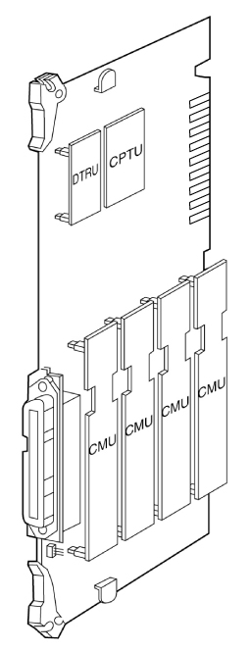

Fig 3.4.8 CMU & CPTU & DTRU Installation

3.4.5.2 LCOB8 Installation

LCOB8 provides 8 Loop Start CO line interfaces. The board can be optionally equipped with two Call Metering Unit (CMU4) boards to monitor call charge and a Call Progress Tone Unit (CPTU4) board to monitor call progress signals and a DTMF Receiver Unit (DTRU4) to detect DTMF.
A CMU4 supports 4 channels call metering function. And the appropriate type of CMU4 should be installed on the line according to the national specification.
If required, install the DTRU4, CMU4s and CPTU4 on the CO interface board as shown in Fig 3.4.12.

LDK-300 LCOB8 Iss: Rev:
CN2
●
CN9
DTRU4
SERVICE
NORMAL
………
CPTU4
…...
CN8
ON:COUNTRY
OFF:CTR21
●
●
CMU4
CMU4
CN4
CN6
CN5
CN7

SW2
CN3

SW1

Fig 3.4.11 LCOB8, CMU4, CPTU4 and DTRU4 configuration

Function of Switch
SW | Function | Remark
SW1 | Mode selection switch  ON : Country mode  OFF : CTR21 mode | 1), 2)
SW2 | Upper Side - Normal Operation((short loop)  Lower Side - Service Position(long loop) | 3), 4)
Table 3.4.20 Switch on LCOB8
- Note:
- Country mode : H/W gain and transmission characteristics depend on Each country Spec.
- CTR21 mode : H/W gain and transmission characteristics depend on CTR21 Specification.
3) LDK-300 does not support the function of normal/service selection.
4) SW2 is used for selection of short loop or long loop in special country.
[ special country( impedance = 600ohm ) : Standard, India, Israel, China ]

Function of LED
LED | Function | Remark
LED1 | The status of line 1, ON: in use, Green
LED2 | The status of line 2, ON: in use, Green
LED3 | The status of line 3, ON: in use, Green
LED4 | The status of line 4, ON: in use, Green
LED5 | The status of line 5, ON: in use, Green
LED6 | The status of line 6, ON: in use, Green
LED7 | The status of line 7, ON: in use, Green
LED8 | The status of line 8, ON: in use, Green
Table 3.4.21 LED on LCOB8
Function of various connectors
Connector | Function | Remark
CN2 and CN3 | DTRU4 connection
CN8 and CN9 | CPTU4 connection
CN4 and CN5 | The connectors for a CMU4 on line 1~4
CN6 and CN7 | The connectors for a CMU4 on line 5~8
CN10 | Connection between GND and Tel Ground(TEGND) for 50Hz longitudinal meter pulse | 1)
CN1 | RJ21 type male connector for CO line connection and TEGND
Table 3.4.22 Connector on LCOB8
- Note:
- The pin #2 and #3 of CN10 should be shorted by shorting traps (short pin) when 50Hz longitudinal meter pulse is used for call charge.

LCOB8 can be installed in any one of slot No. 1-9 in KSU.
Add-on boards: DTRU4, CPTU4, CMU4_50PR / CMU4_12PR / CMU4_16

DTRU4

CPTU4

CMU4

CMU4

Fig 3.4.12 CMU4 & CPTU4 & DTRU4 Installation

3.4.5.3 EMIB4W

The EMIB4W provides 4 analog E&M interfaces. It can only support type V of the E&M signaling.
It is designed to comply with the Australian specification.

Function of LED
LED | Function | Remark
LED1 | The status of line 1, ON: in use
LED2 | The status of line 2, ON: in use
LED3 | The status of line 3, ON: in use
LED4 | The status of line 4, ON: in use
Table 3.4.25 LED on EMIB4W

Function of various connectors and switches
Connector | Function | Remark
CN1 and CN2 | DTRU connection
CN3 | The champ connector for connecting the E&M Tie lines
CN7~CN10 | The selection of 2 wire or 4 wire E&M
SW1 | The RX gain control; OFF: normal gain, ON: 6db gain up | Default: OFF
SW2 | The TX gain control; OFF: normal gain, ON: 6db gain up | Default: OFF
Table 3.4.26 Connector & Switch on EMIB4W

2 wire/4 wire selection
This board can support 2 wire and 4 wire E&M depending on the connection of the short pin assembled on the CN7~CN10. When EMIB4W is assembled in the factory, the short pin is set to 4 wire connection. Refer to the following Figure 3.4.14 for the detail connection method.
NOTE: this does not apply to the Australian board, which only supports 4 Wire working.

3
2
1
3
2
1
(Factory setting)

(The connection for 2 wire E&M) (The connection for 4 wire E&M)
Figure 3.4.14 The short pin connection diagram of CN7~CN10
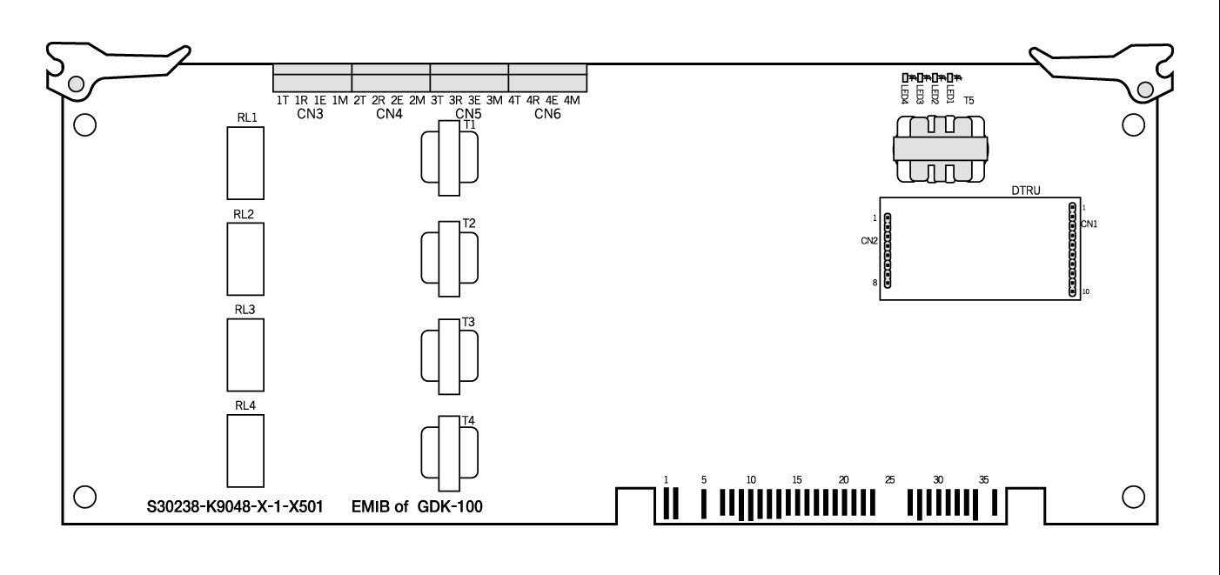

Fig 3.4.15 Board Layout and DTRU installation

3.4.5.5 VOIB Installation

The VOIB/VOIU can be installed in the Aria-300 KSU.
Its main job is to provide the Ethernet interface for S/W applications and VoIP features with optional VoIP daughters.
The VOIB has the capacity for maximum four(4) VOIUs, and each VOIU provides two(2) VoIP channels.
Ethernet Status
T1
CN4
CN5
CN7
CN1
CN3
Ch. Status LED
LD1 ……. LD8
SW4
CN11
SW1
1 ………. 8
SW2
●
●
CN9
VoIP
Card 1
VoIP
Card 2
VoIP
Card 3
VoIP
Card 4
●
●
●
●
●
●
.
.
.
.
.
●
●
CN2
LD14…..LD9
CN6
CN8

V100, LDK-300 LAN BOARD
CN1
■■■■■■■■■■■
■■■■■■■■■■■
■■■■■■■■■■■
■■■■■■■■■■■
CN2
VoIP
Daughter
Board
(Location : CN1-CN2, CN3-CN4, CN5 - CN6, CN7-CN8)

Fig 3.4.17 VOIB and VOIU installation

Function of various switches and connectors
Switch / Connector | Functions | Remark
SW1 | Hardware Reset Switch for CPU (MPC860)
SW2 | To be determined
SW4 | OOS(Out Of Switch)  Upper Side - Normal Operation  Lower Side - Service Position
CN1 and CN2 | VoIU Board #1 Connection
CN3 and CN4 | VoIU Board #2 Connection
CN5 and CN6 | VoIU Board #3 Connection
CN7 and CN8 | VoIU Board #4 Connection
CN9 | Serial Interface(RS-232C) Connection
CN11 | BDM(Background Debug Mode) Connection
Ethernet Connector T1 | Network(RJ-45) Cable Connection
Table 3.4.29 Switch & Connector on VOIB

Function of LEDs
LED | Functions | Remark
LD1 ~ LD8 | Channel Status LED(ON : Busy, OFF : Idle)
LD9 | Speed Status LED(ON : 100Mbps, OFF : 10Mbps)
LD10 | Receive Status LED(ON : Receive, OFF : Idle)
LD11 | Transmit Status LED(ON : Transmit, OFF : Idle)
LD12 | Link Status LED(ON : Link OK, OFF : No Link)
LD13 | Collision Status LED(ON : Collision, OFF : Normal Operation)
LD14 | Full-Duplex Status LED(ON : Half-Duplex, OFF : Full-Duplex)
Table 3.4.30 LED on VOIB

The board is installed in any of slot No. 1-9 except only slot No. 9 of 1’st KSU.
The basic LAN board has the capacity for maximum four(4) VOIU, and each VOIU provides two(2) VoIP channels.

Add-on board : VOIU 1 – VOIU 4

3.4.5.6 VOIU Installation

VOIU consists of One(1) DSP, One(1) data memory and One(1) DC/DC converter.
VOIU is used to voice compression and de-compression.
The AC48302C-C Voice over Packet Network Processor AC48302C-C VoPNP is a state-of-the-art system on a single chip.
It provides configurable, low-bit-rate voice compression and fax relay functions for up to Two(2) independent PCM voice and fax channels.

ISDN Board Installation

There are 3 kinds of ISDN boards such as PRIB, BRIB, and STIB are available. Each ISDN board contains RJ45 type jack on boards themselves.

ISDN BRIB (Basic Rate T interface) Installation

The BRIB card provides 4 interface circuits of BRI (Basic Rate Interface) format digital CO interface.
If more than one ISDN board is required, some special cable should be used for clock signal control. CON3 and CON4 are used to control the clock signal when multi-ISDN boards are installed. Refer to [Clock Control Cable Wiring] of section 3.5.7.5.

Function of LED
LED | Function | Status | Remark
LED1 | The status of Line 1 | Red: Error, Green: In-use, OFF: Idle
LED2 | The status of Line 2 | Red: Error, Green: In-use, OFF: Idle
LED3 | The status of Line 3 | Red: Error, Green: In-use, OFF: Idle
LED4 | The status of Line 4 | Red: Error, Green: In-use, OFF: Idle
Table 3.4.16 LED on BRIB

Function of SW1; default -all OFF when delivering the board
Pole | Function | ON | OFF | Remark
1 | Not used | - | -
2 | TEI | Fixed TEI | Automatic TEI | Note 1, 2
3 | Layer 2 trace | Enable | Disable | Note 3
4 | Layer 3 trace | Enable | Disable | Note 3
Table 3.4.17 switch on BRIB
- Note:
- The function of the 2nd pole has been implemented in firmware version 3.1 or later.
- This is set to OFF position as default, therefore it is important to note that the 2nd pole is set to the proper position after checking the type of TEI in your country. (In Australia, this pole should be ON).
- These two poles are for the purpose of developing and maintaining BRIB.

Function of various connectors
Connector | Function | Remark
CON1 | Serial interface connector | Note1
CON2 | The purpose of development. It is not fixed on the products.
CON3 | Clock control IN | Note 2
CON4 | Clock control OUT | Note 2
Table 3.4.18 connector on BRIB
- Note
- CON1: Trace for the purpose of development and maintenance.
- CON3, CON4: They are used to control the reference clock signal when multi-ISDN boards are installed.

The line connector and terminating resistors
Line No | RJ45 type jack | Terminating Resistors
Line No | RJ45 type jack | Switch | All ON | All OFF
Line 1 | CON8 | SW5 | terminating | open
Line 2 | CON7 | SW4 | terminating | open
Line 3 | CON6 | SW3 | terminating | open
Line 4 | CON5 | SW2 | terminating | open
Table 3.4.19 Line connector on BRIB
- Note
- Two poles of SW2, SW3, SW4 and SW5 should be set to the ON position to terminate two terminating resistors on a line. (default ON)
- Terminating resistors and selectable switches are introduced only on PCB issue 3 or later, but not on PCB issue 1 and 2. So if you use BRIB issue 1 and 2, the external terminating resistors are required. For the external termination, you can get the terminating unit locally or use GDK-162/100 TERM, which is the terminating unit with 4 P-to-P connections provided by LGE.
RJ45
CON5
CON3(IN)
SW1
1 2 3 4
GDK-100 BRIB
LED1
LED2
LED3
LED4
CON4(OUT)
CON1
U11
(ROM1)
U10
(ROM2)
RJ45
CON6
RJ45
CON7
CON2
RJ45
CON8
1 2 3 4
SW5
1 2
ON
OFF
SW4
1 2
ON
OFF
SW3
1 2
ON
OFF
SW2
1 2
ON
OFF

Fig 3.4.9 BRIB Layout
Check Points
- BRIB boards should be installed in any of the slot No. 1-8 in the 1st KSU, Slot No. 1~9 in the 2nd and 3rd KSU.
- The 2nd pole of SW1 should be set to the proper position according to the type of TEI.
- The RX and TX pairs of line should be correctly connected to the TX and RX pairs of NT1.
- The clock control cable should be connected to the proper position when multi-ISDN cards are installed in a system. See section 3.5.7.5.
- Terminating resistors on the line.

ISDN STIB ( Basic Rate S/T Interface) Installation

STIB card provides 4 interface circuits of Basic Rate format digital CO and/or Extension interface. If more than one ISDN board is required, some special cable should be used for clock signal control. CON3 and CON4 are used to control the clock signal when multi-ISDN boards are installed. Refer to [Clock Control Cable Wiring] of section 3.5.7.5.

Function of LED
Line No | Function | Status | Remark
LED1 | The status of Line 1 | Red: Error, Green: In-use, OFF: Idle
LED2 | The status of Line 2 | Red: Error, Green: In-use, OFF: Idle
LED3 | The status of Line 3 | Red: Error, Green: In-use, OFF: Idle
LED4 | The status of Line 4 | Red: Error, Green: In-use, OFF: Idle
Table 3.4.20 LED on STIB

Function of SW1: default - all OFF when delivering the board
Pole | Function | ON | OFF | Remark
1 | Not used | - | -
2 | TEI | Fixed TEI | Automatic TEI | Note 1, 2
3 | Layer 2 trace | Enable | Disable | Note 3
4 | Layer 3 trace | Enable | Disable | Note 3
Table 3.4.21 switch on STIB
- Note:
- The function of 2nd pole has been implemented in firmware version 3.1 or later.
- This is set to OFF position as default, therefore it is important to note that 2nd pole is set to the proper position after checking the type of TEI in your country. (In Australia, this pole should be ON).
- These two poles are for the purpose of developing and maintaining STIB.

Function of various connectors
Connector | Function | Remark
CON1 | Serial interface connector | Note1
CON2 | The purpose of development. It is not fixed on the products.
CON3 | Clock control IN | Note 2
CON4 | Clock control OUT | Note 2
Table 3.4.22 connector on STIB
- Note
- CON1: Trace for the purpose of development and maintenance.
- CON3, CON4: They are used to control the reference clock signal when multi-ISDN boards are installed. See [Clock Control Cable Wiring] on section 3.5.7.5.

The line connector and termination switches
Line No | RJ45 type Jack | S/T selection |  |  | Terminating Resistors
Line No | RJ45 type Jack | Switch | all to “T “ | All to “S” | Switch | all to ON | all to OFF
Line 1 | CON8 | SW4 | T | S | SW9 | terminating | open
Line 2 | CON7 | SW3 | T | S | SW8 | terminating | open
Line 3 | CON6 | SW2 | T | S | SW7 | terminating | open
Line 4 | CON5 | SW5 | T | S | SW6 | terminating | open
Table 3.4.23 Line connector on STIB
- Note:
- The setting method of S/T selection switches: default -all T position when delivering the board.
Each line interface can be used for T interface or S interface with different operation interface. If necessary, the S/T selection switches of SW2, SW3, SW4 and/or SW5 can be respectively set to the T or S position by using shorting traps (short pins) supplied on the boards.
- Two poles of SW6, SW7, SW8 and/or SW9 should set to the ON position to terminate two terminating resistors on a line. (default ON)
- Terminating resistors and selectable switches are introduced only on PCB issue 2 or later, but not on PCB issue 1. So if you use STIB issue 1, the external terminating resistors are required. For the external termination, you can get the terminating unit locally or use GDK-162/100 TERM, which is the terminating unit with 4 P-to-P connection provided by LG.

Power does not feeding
Power feeding
POWER
T
S
SW2/SW3/SW4/SW5
Shorting trap
(Short pin)

Fig 3.4.10 Configuration of S/T selection connectors

- Note:
- Each line can be selected to T or S interface according to the needs.
2. After setting all lines respectively, the slot(s) of STIB must be assigned as CO slot(s) and STA slot(s) together in Admin field 02 for the proper operation of STIB. See the clause 4.2 and the Programming Manual.

Check Points
- STIB can be installed in any of the slot No. 1-8 in the 1st KSU, and slot No. 1~9 in the 2nd and 3rd KSU.
- Each interface should be set to the correct type, T or S with S/T selection connectors, according to the needs of user. And the RX and TX pairs of line should be correctly connected to the TX and RX pairs of NT1 or TE according to the interface type of each line.
- Terminating resistors on the line.
- The 2nd pole of SW1 should be set to the proper position according to the type of TEI.
- The clock control cable should be connected to the proper position when multi-ISDN cards are installed in a system. See section 3.5.7.5.
RJ45
CON5
CON3(IN)
SW1
1 2 3 4
GDK-100 STIB
LED1
LED2
LED3
LED4
CON4(OUT)
CON1
U10
(ROM2)
U11
(ROM1)
RJ45
CON6
RJ45
CON7
CON2
RJ45
CON8
1 2 3 4
SW9
1 2
ON
OFF
SW8
1 2
ON
OFF
SW7
1 2
ON
OFF
SW6
1 2
ON
OFF
CON13
T
S
SW4
T
S
SW3
T
S
SW2
T
S
SW5

Fig 3.4.11 STIB Layout

ISDN PRIB ( Primary Rate Interface) Installation

The PRIB card provides one interface circuit of PRI (Primary Rate Interface) format digital CO interface.
If more than one ISDN board is required, some special cables should be used for clock signal control. CON6 and CON7 are used to control the clock signal when multi-ISDN boards are installed. Refer to [Clock Control Cable Wiring] of section 3.5.7.5.

Function of LED
LED | Function | Status |  | Remark
LED | Function | ON | OFF | Remark
LED1 | PLL Synchronization | Sync. Error | Normal
LED2 | Loss Of Signal from the Line | LOS | Normal
LED3 | AIS | Alarm error | Normal
LED4 | Frame Alignment Error | Error | Normal
LED5 | Multi-frame Error | Error | Normal
LED6 | Remote Alarm Error | Error | Normal
LED7 | CRC Error | Error | Normal
LED8 | The status of the line | In use | All channel idle
Table 3.4.24 LED on PRIB
- Note:
- All LEDs will be the status of OFF when normal operation.
- When PRI line is plugged out, LED 2, 4 and 5 will be ON.

Function of SW1: default - all OFF when delivering the board
Pole | Function | ON | OFF | Remark
1 | CRC | Disable | Enable
2 | Loop back | Enable | Disable | Note 1
3 | Not used | - | -
4 | Trace | Enable | Disable | Note 2
Table 3.4.25 switch on PRIB
- Note:
- This pole is for the purpose of testing PRIB.
- This pole is for the purpose of developing and maintaining PRIB.

Function of various connectors
Connector/Switch | Function | Remark
CON1 | Serial interface connector( 4pin) | Note 1
CON2 | The purpose of the software development.
CON3 | NT/TE mode selection for QSIG. ( Default: open - TE) | Note 2
CON5 | Serial interface connector(9-pin RS232C, male) | Note 1
CON6 | Clock control IN | Note 3
CON7 | Clock control OUT | Note 3
CON8 | RJ45 type jack for PRI Line connection | Clause 3.5
Table 3.4.26 connector on PRIB

- Note
- Development purposes only.
- CON3: NT/TE mode selection
Open circuit between 2 pins: TE mode (normal operation)
Short circuit between 2 pins: NT mode (Special operation, e.g. NT mode in QSIG operation)
- CON6, CON7: They are used to control the clock signal when multi-ISDN boards are installed.
See [Clock Control Cable Wiring] on section 3.5.7.5.

Fig 3.4.12 PRIB Layout
GDK-100 PRIB
RJ45
CON8
LED8
CON6(IN)
SW1
U200
(ROM2)
1 2 3 4
1 4
LED1
LED2
LED3
LED4
LED5
LED6
LED7
CON7(OUT)
CON3(TEST)
CON2(JT)
CON1
CON5
U201
(ROM1)

Check Points
- One PRIB should be installed on one of the slot No. 1-8 in the 1st KSU, and slot No. 1-9 in the 2nd and 3rd KSU.
- For QSIG operation, check the mode setting method and the contact assignments of RJ45 type connector according to the mode of line , TE or NT. See the clause 3.5.7.
- The clock control cable should be connected to the proper position when multi-ISDN cards are installed in a system. See section 3.5.7.5.

VMIB (Voice Mail Interface Board) Installation

VMIB provides system announcement, ACD/UCD announcement, and User Greeting. If necessary, the FMEU(Flash Memory Expansion Unit) can be installed on VMIB for the expansion of User Greetings. And, if necessary, the VCEU(ADPCM Unit) can be installed on VMIB for the expansion of user access channels.

Fig 3.4.13 VMIB PCB layout

Function of LED
No | Description | Status |  | Remark
No | Description | ON | OFF | Remark
LED1 | The status of channel 1 | In use | Idle
LED2 | The status of channel 2 | In use | Idle
LED3 | The status of channel 3 | In use | Idle
LED4 | The status of channel 4 | In use | Idle
LED5 | The status of channel 5 | In use | Idle
LED6 | The status of channel 6 | In use | Idle
LED7 | The status of channel 7 | In use | Idle
LED8 | The status of channel 8 | In use | Idle
LED9~11 | Not assemble
LED12 | Reserved
Table 3.4.27 LED on VMIB

Function of various connectors
Connector | Function | Remark
CN1 | Serial interface connector( 4pin) for trace | Note 1
CN2 | For the purpose of development | Note 2
CN3, CN6, CN7 | Not used
CN4~CN5 | VCEU expansion connector
CN8~CN9 | FMEU expansion connector
PJ1, PJ2 | Not used
Table 3.4.28 connector on VMIB
- Note
- CN1: Trace for the purpose of development and maintenance.
The external module for RS-232C serial interface should be required for trace using this connector. See GDK-TRC1 in section 2.4.15.
- CN2: It is impossible to use them for user access.
These connectors are usually used for the purpose of development and production test.

Function of various switches
Switch | Function | Remark
SW1 | SRAM back-up when power interruption or failure | ON
SW2 | CPU reset
SW3, SW5 | Not used | Not Used
SW4 | Service/Normal | Normal
Table 3.4.29 switch on VMIB
- Note
- SW1: This is for the purpose of SRAM back-up for ACD/UCD announcement.
It should be turned ON during installing the VMIB, to protect announcements in the case of a power fail.

Lithium Battery
“Caution:
Danger of explosion if the battery is incorrectly replaced.
Replace only with the same or equivalent type recommended by the manufacturer.
Dispose of used batteries according to the manufacturers instruction.”

- SW4 : This is for the purpose of the state of “in service” or “normal operation”.

Add-on boards: FMEU, VCEU

